John Paul II Awards

A large number of students from Mount Lourdes received their John Paul II awards at a function in the Slieve Russell Hotel, Ballyconnell, recently. Having carried out volunteer work in their own parish or in school, students received a Gold, Silver or Bronze award.

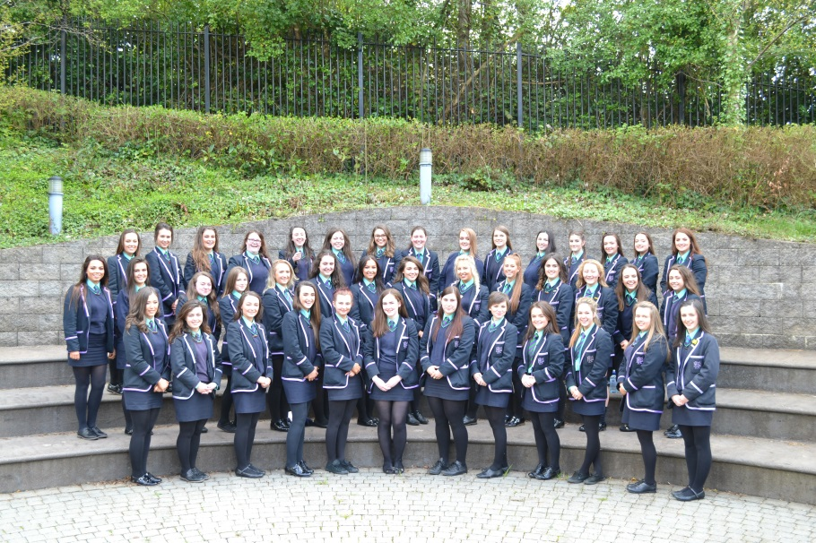

Government and Politics Students’ Trip to Dublin
Year 14 Government and Politics students, accompanied by their teachers, Mrs Devine and Mrs McGeoghan, visited The Irish Oireachtas in Leinster House, Dublin, to experience first-hand the workings of the Irish Parliament.

They visited both the Seanad and the Dail, enabling students to learn about the history of The Irish Republic whilst witnessing the workings of a legislature in action.

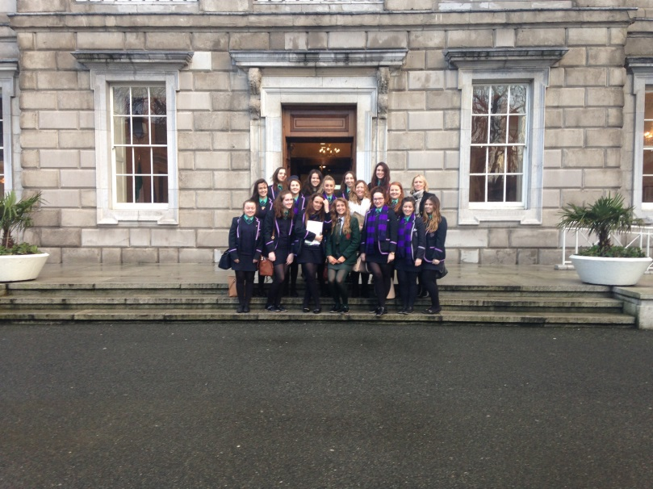

Year 13 Government and Politics Students Visit Stormont
In support of their studies, the Year 13 Government and Politics class made their way to Parliament Buildings, Stormont, to see how government operates north of the border.

During the day, students were addressed by Deputy First Minister, Martin McGuinness. Students also had the opportunity to question the First Minister, Arlene Foster, and the then Justice Minister, David Ford. The day ended with a visit to the Assembly Chamber.

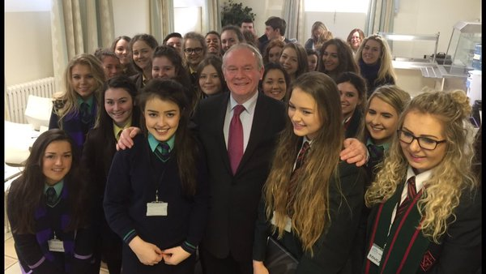

Year 8 Gaelic Football Team wins Ulster Tournament

Our Year 8 Gaelic Football teams travelled to Cookstown to play in the Year 8 Ulster Tournament.

The A team, captained by Ciana Mc Grath, secured victory over Our Lady’s Grammar School, Newry in the semi-final before winning the final against Dean Maguirc College, Carrickmore.

The B team also had a very successful run in the tournament, narrowly losing to St. Ciaran’s, Ballygawley.

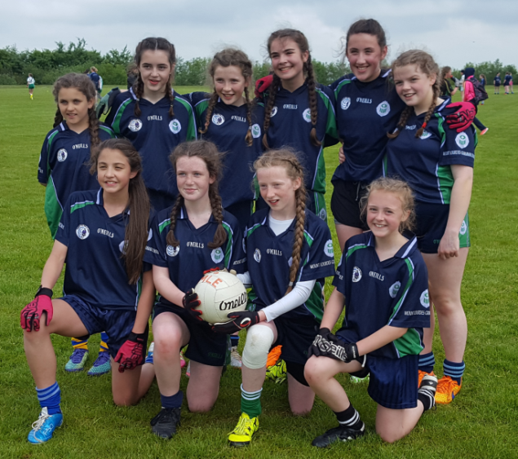

The Year 8 Gaelic Football ‘A’ team. Back row from left: Aloisia Donohoe, Aisling Keenan, Niamh McAloon, Ciana McGrath, Farrah McCloskey and Aoife Keaney. Front from left: Caragh Leonard, Aine McBrien, Reisha McCaughey and Aoife McCabe.

Swimming

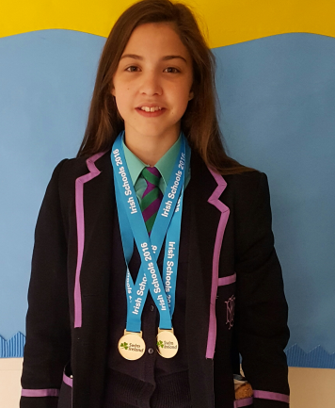
Caragh Leonard, Year 8, claimed Gold medals in 50m Breast Stroke and in the 50m Front Crawl in the Irish Minor Schools’ Competitions.

Celebration of Sport

‘Celebration of Sport’ is an annual event which celebrates successful athletes and teams from Northern Ireland. The event offers local clubs and representatives from a variety of sporting organisations the opportunity to try a wide range of sports and to meet some of Northern Ireland’s sporting greats.

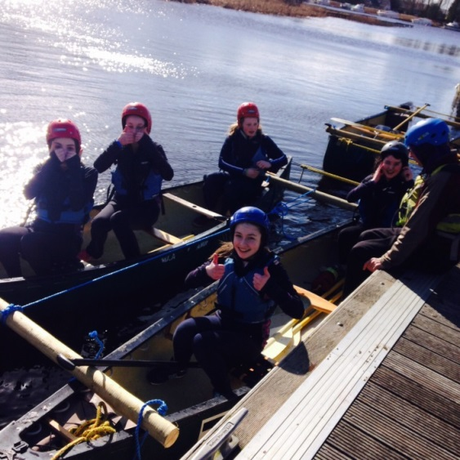
Year 10 students attended the event which was held in the Lakeland Forum, Enniskillen. They met sporting heroes including Northern Ireland goalkeeper, Roy Carroll, and Ulster Rugby Scrum-Half, Paul Marshall.
