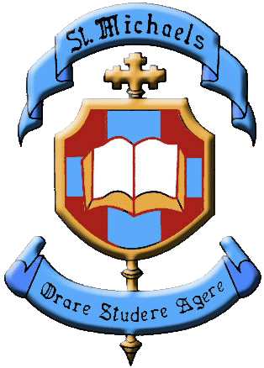
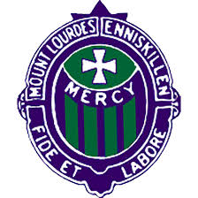

Important information for Parents and Guardians of Primary Six pupils in relation to Transfer 2021-22 in the Fermanagh / South West Tyrone area.

The Trustees, Boards of Governors and Principals of Mount Lourdes Grammar School and St. Michael’s College have considered the impact of school closures on our local community. They recognise that there has been significant disruption to the education of pupils since March 2020, including that of P6 pupils and understand that there may be further disruption during the 2020-21 academic year.

The Boards of Governors and Principals of Mount Lourdes Grammar School and St. Michael’s College have agreed, in light of the current circumstances, and for one year only, that neither school will use outcomes from the GL Entrance Assessment as part of their Admissions Criteria for the academic year 2021-22. Pupils applying to these schools will not be required to provide a GL Entrance Assessment result.

Mount Lourdes and St. Michael’s will temporarily amend their Admissions Criteria for the 2021-22 academic year accordingly.

Each school’s Admissions Criteria will be published by the Education Authority (EA) according to its normal timetable.

Both schools remain committed to Catholic Ethos with a focus on pastoral care and high quality learning and teaching. Those who would normally apply to be admitted to each individual school are encouraged to continue to do so.

Yours faithfully,

Mrs Una Porteous Monsignor Peter O’Reilly, PP, VG.

Chair of St. Michael’s Board of Governors Chair of Mount Lourdes Board of Governors

Mark Henry Sinead Cullen

Principal St. Michael’s College Principal Mount Lourdes Grammar School

